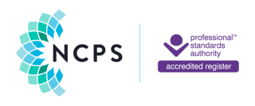

**Accredited Registrant**

**MEMBERSHIP CERTIFICATE**

*Having fulfilled the required criteria, the practitioner named below is considered by the Society to be safe, competent and ethical to practise the vocation of*

*counselling/psychotherapy and is thus recorded on the Society Register with AccreditedRegistrant Membership and the designation* ***MNCPS (Acc.).***

**Madelaine Freedman**

*This certificate was issued on 12th February 2025 and is valid only until 26th February 2026. It remains the property of the Society at all times.*

*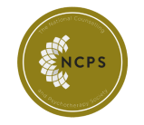***Signed by**

**image4.png**

Katy Godzik-Brooks,

Membership Services Lead

**MEMBERSHIP NO: NCS23-00780**

The National Counselling & Psychotherapy Society, 19 Grafton Road, Worthing, West Sussex, BN11 1QT. T: 01903 200 666 hello@ncps.com www.ncps.com

Registered in England No. 5861051